1. Home Page

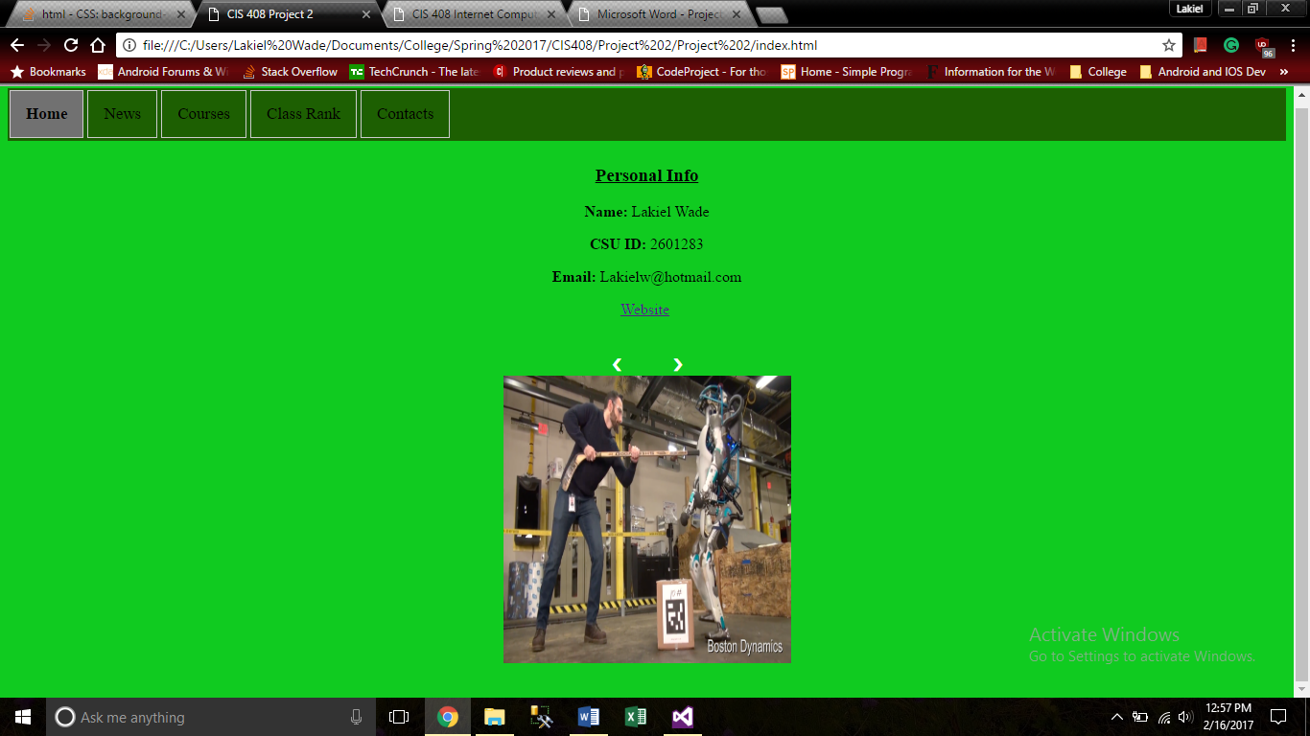

1. News Page

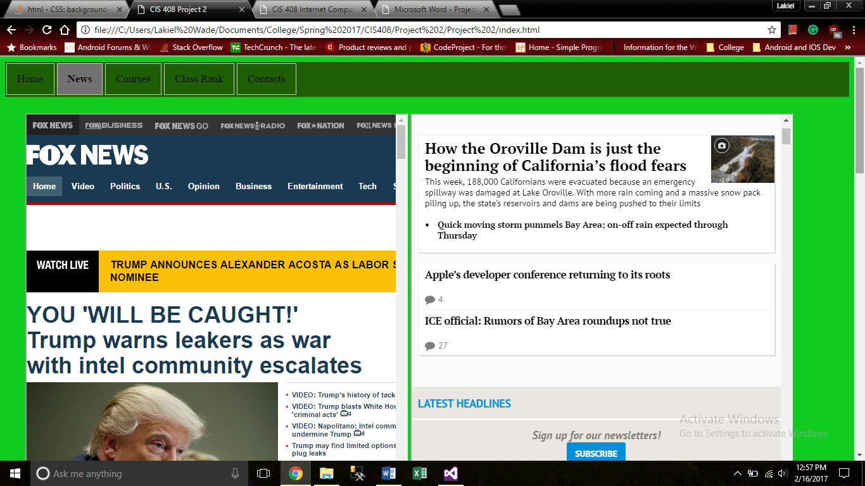

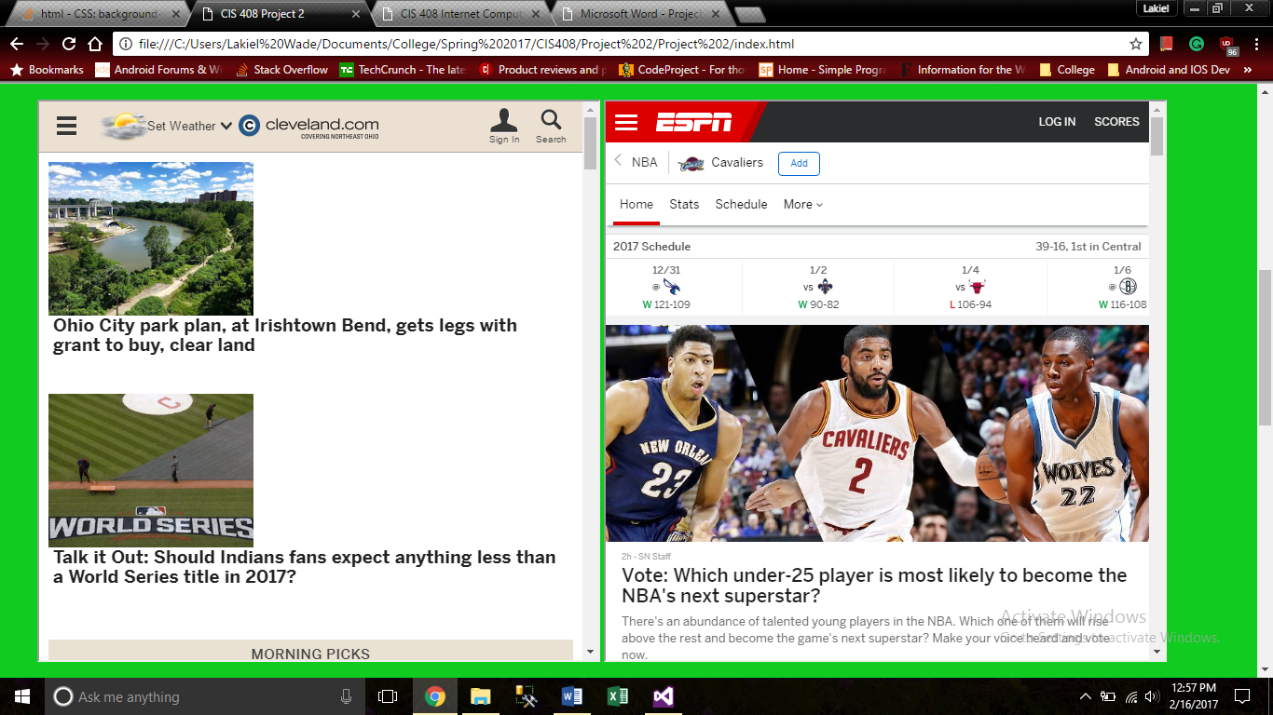

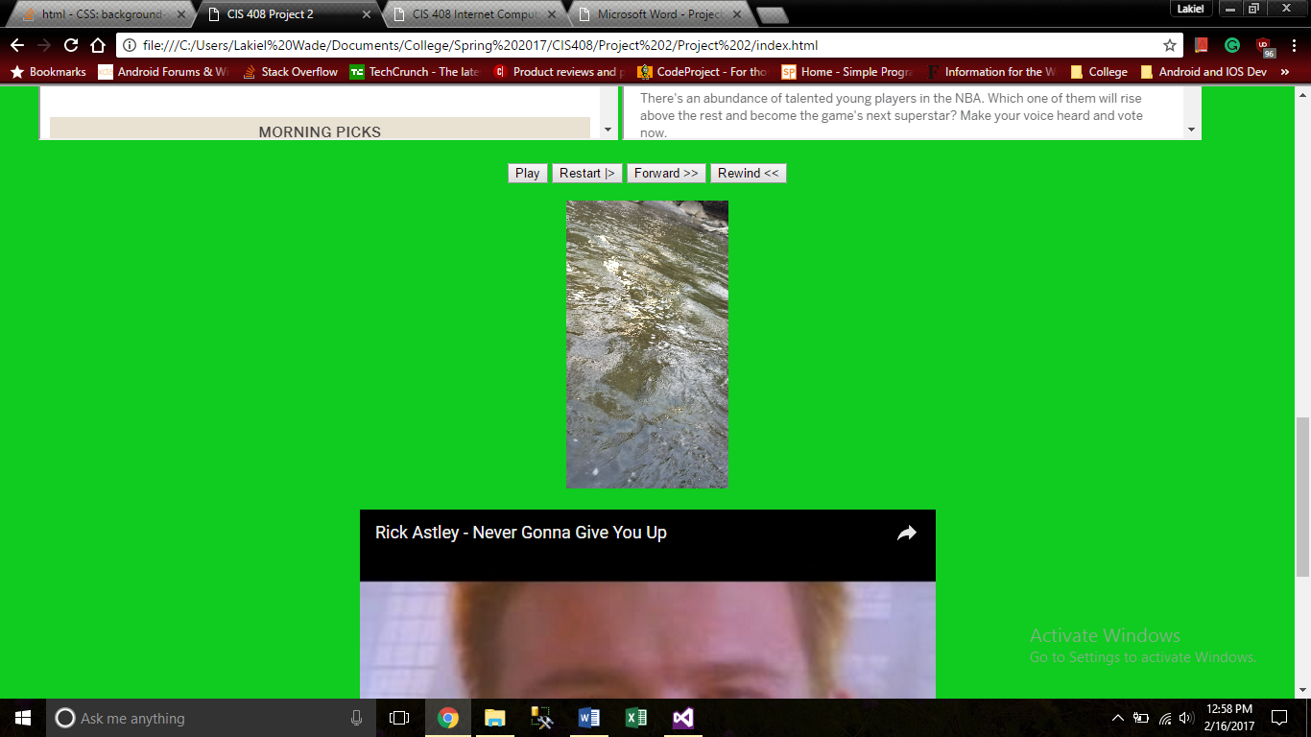

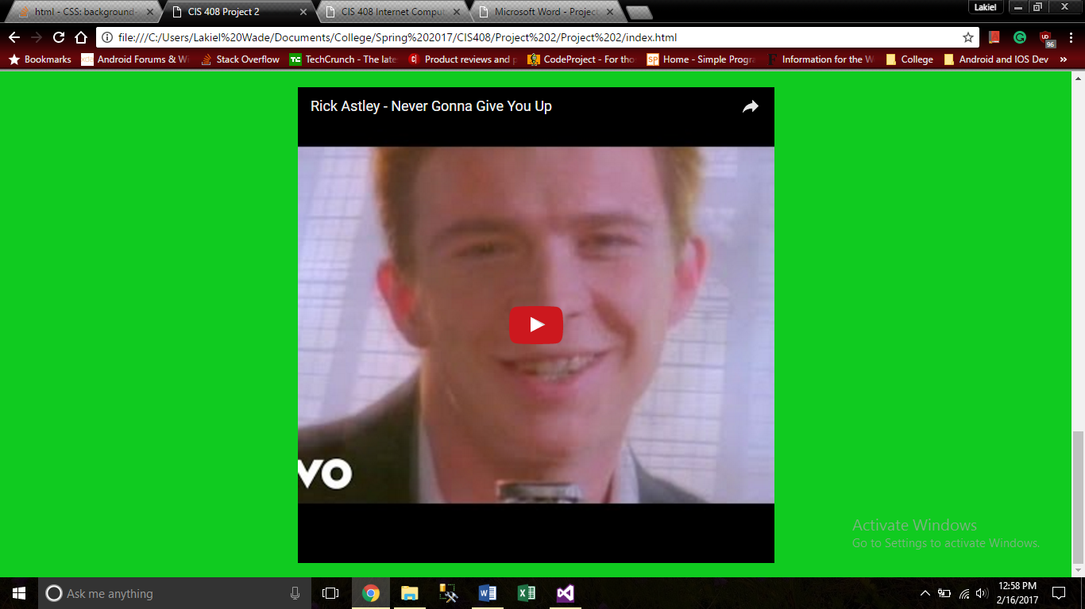

1. Courses Page

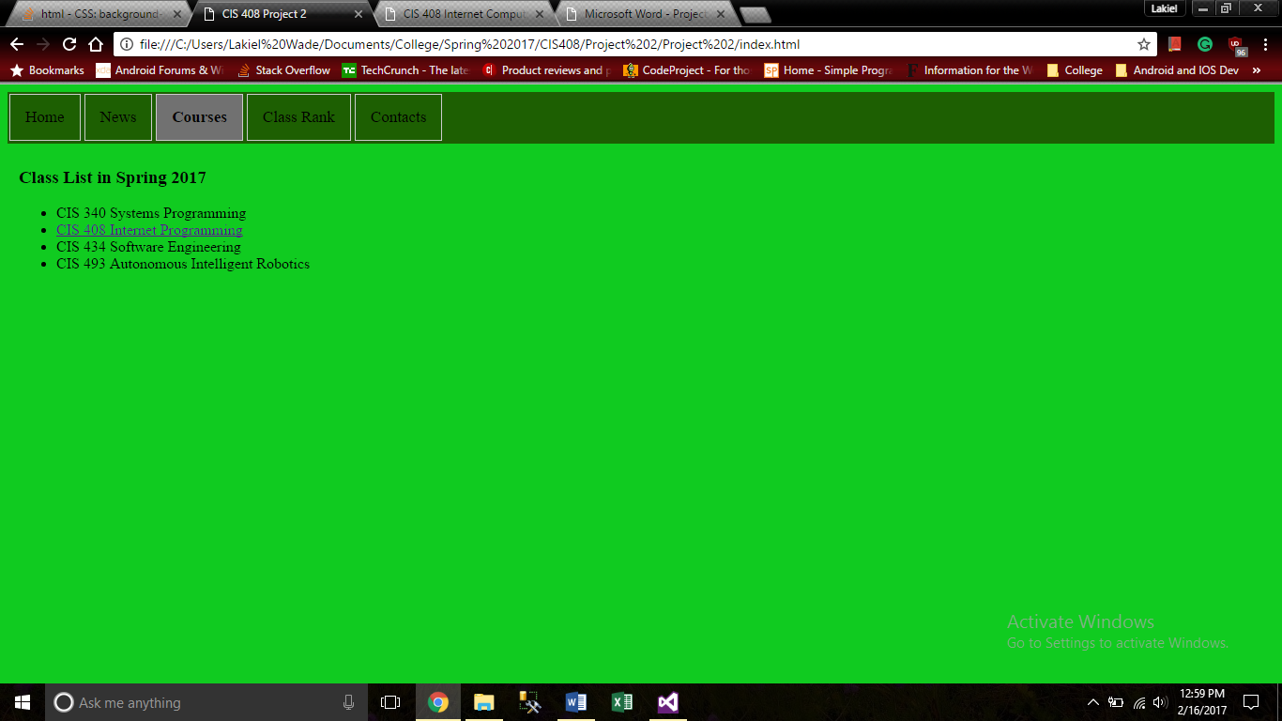

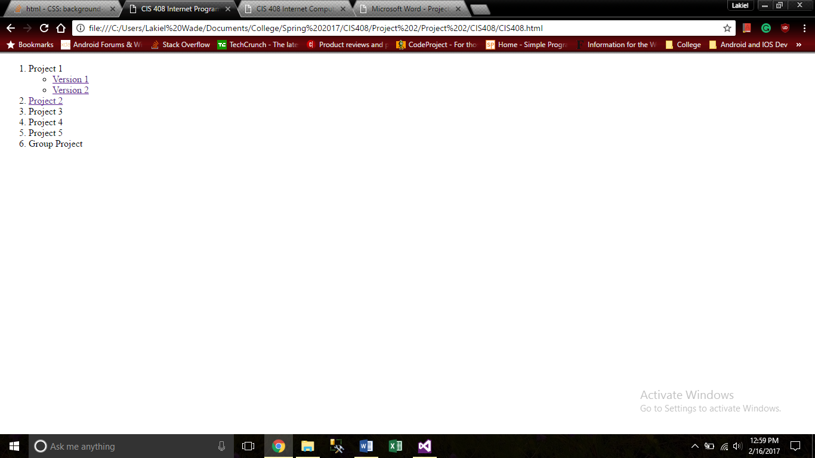

1. Class Rank

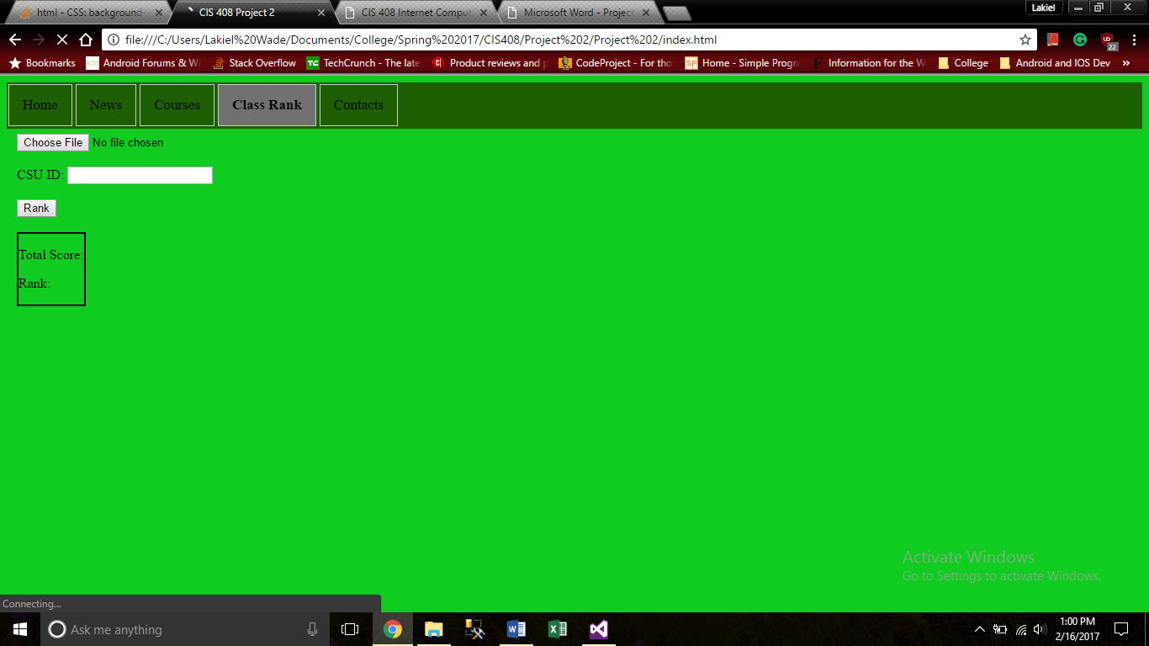

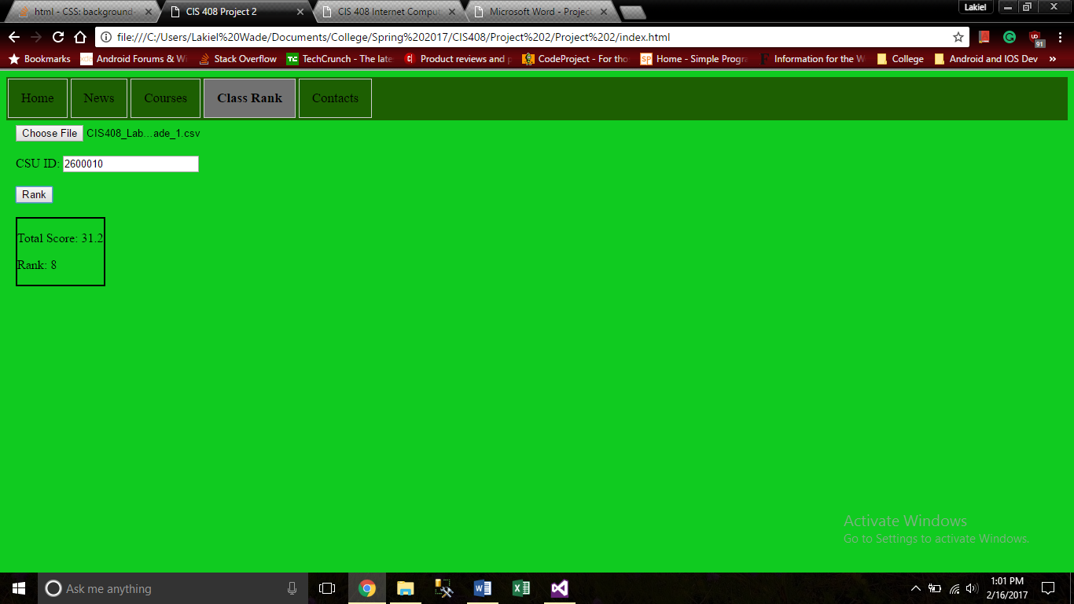

1. Contacts

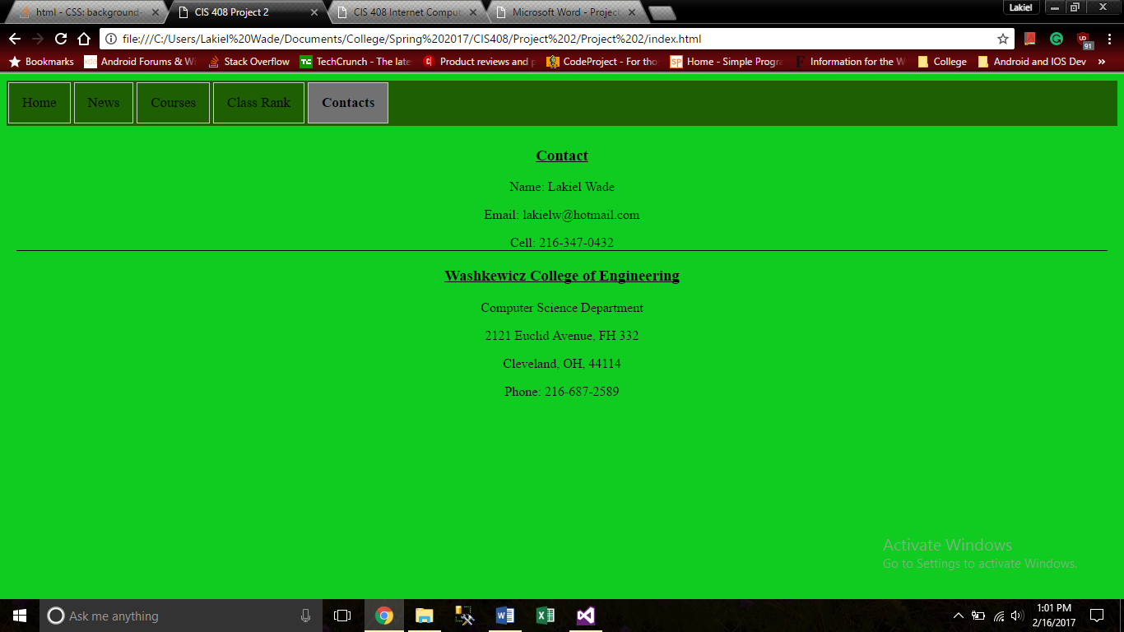

1. Source Code
   1. Html

<!DOCTYPE html>

<html>

<head>

<link rel="stylesheet" type="text/css" href="p2.css" />

<meta charset="utf-8" />

<title>CIS 408 Project 2</title>

</head>

<body>

<ul class="tab">

<li><a class="tablinks" onclick="openCity(event, 'Home')" id="defaultOpen">Home</a></li>

<li><a class="tablinks" onclick="openCity(event, 'News')">News</a></li>

<li><a class="tablinks" onclick="openCity(event, 'Courses')">Courses</a></li>

<li><a class="tablinks" onclick="openCity(event, 'Class Rank')">Class Rank</a></li>

<li><a class="tablinks" onclick="openCity(event, 'Contacts')">Contacts</a></li>

</ul>

<div id="Home" class="tabcontent">

<div style="text-align:center">

<h3><u>Personal Info</u></h3>

<p><b>Name:</b> Lakiel Wade</p>

<p><b>CSU ID:</b> 2601283</p>

<p><b>Email:</b> Lakielw@hotmail.com</p>

<a href="http://grail.eecs.csuohio.edu/~lawade">Website</a>

<br />

<br />

<br />

<div class="slideshow-container">

<a class="prev" onclick="plusSlides(-1)">&#10094;</a>

<a class="next" onclick="plusSlides(1)">&#10095;</a>

<div class="mySlides fade">

<img src="Images/robot1.jpeg" width="300" height="300">

</div>

<div class="mySlides fade">

<img src="Images/robot2.png" width="300" height="300">

</div>

<div class="mySlides fade">

<img src="Images/robot3.jpg" width="300" height="300">

</div>

</div>

<br />

</div>

</div>

<div id="News" class="tabcontent">

<section style="margin:20px;">

<iframe src="http://www.foxnews.com/"></iframe>

<iframe src="http://www.mercurynews.com/"></iframe>

</section>

<section style="margin:20px;">

<iframe src="http://www.cleveland.com/#/0"></iframe>

<iframe src="http://www.espn.com/nba/team/_/name/cle/cleveland-cavaliers"></iframe>

</section>

<div style="text-align:center">

<div class="videoBlock">

<div class="videoControls">

<button id="play" onclick="PlayPause()">Play</button>

<button id="pause" onclick="PlayPause()">Pause</button>

<button onclick="Restart()">Restart |> </button>

<button onclick="Forward()">Forward >></button>

<button onclick="Rewind()">Rewind << </button>

</div>

<br />

<video id="video">

<source src="Video/Waterproof_test.mp4" type="video/mp4" />

</video>

</div>

<br />

<iframe class="iframevideo" src="https://www.youtube.com/embed/dQw4w9WgXcQ" frameborder="0"></iframe>

</div>

</div>

<div id="Courses" class="tabcontent">

<h3>Class List in Spring 2017</h3>

<ul>

<li>CIS 340 Systems Programming </li>

<li><a href="CIS408/CIS408.html">CIS 408 Internet Programming</a></li>

<li>CIS 434 Software Engineering</li>

<li>CIS 493 Autonomous Intelligent Robotics</li>

</ul>

</div>

<div id="Class Rank" class="tabcontent">

<input id="csv" type="file" />

<br /><br />

CSU ID: <input type="text" name="ID" id="sID">

<br /><br />

<button onclick="csvJSON()">Rank</button>

<br />

<br />

<div class="rankresults">

<p id="sTotal">Total Score:</p>

<p id="sRank">Rank:</p>

</div>

</div>

<div id="Contacts" class="tabcontent">

<div class="contact">

<h3><u>Contact</u></h3>

<p>Name: Lakiel Wade</p>

<p>Email: lakielw@hotmail.com</p>

<p style="border-bottom: 1px solid black">Cell: 216-347-0432</p>

<h3><u>Washkewicz College of Engineering</u></h3>

<p>Computer Science Department</p>

<p>2121 Euclid Avenue, FH 332</p>

<p>Cleveland, OH, 44114</p>

<p>Phone: 216-687-2589</p>

</div>

</div>

</body>

</html>

<script src="jquery-3.1.1.slim.js"></script>

<script src="jquery.csv.js"></script>

<script src="JavaScript.js"></script>

* 1. CSS

/* Style the list */

body {

background-color: #10cb20;

}

ul.tab {

list-style-type: none;

margin: 0;

padding: 0;

overflow: hidden;

border: 1px solid :#1d5f02;

border-bottom: 1px solid #ccc;

border-color: #1d5f02;

background-color: #1d5f02;

}

/* Float the list items side by side */

ul.tab li {

float: left;

margin: 2px;

border: 1px solid #ccc;

}

/* Style the links inside the list items */

ul.tab li a {

display: inline-block;

color: black;

text-align: center;

padding: 14px 16px;

text-decoration: none;

transition: 0.3s;

font-size: 17px;

}

/* Change background color of links on hover */

ul.tab li a:hover {

background-color: #ddd;

}

/* Create an active/current tablink class */

ul.tab li a:focus, .active {

background-color: #ccc;

font-weight: bold;

}

/* Style the tab content */

.tabcontent {

display: none;

padding: 6px 12px;

border-top: none;

-webkit-animation: fadeEffect 1s;

animation: fadeEffect 1s; /* Fading effect takes 1 second */

}

@-webkit-keyframes fadeEffect {

from {

opacity: 0;

}

to {

opacity: 1;

}

}

@keyframes fadeEffect {

from {

opacity: 0;

}

to {

opacity: 1;

}

}

/* Slideshow container */

.slideshow-container {

max-width: 300px;

position: relative;

margin: auto;

}

/* Next & previous buttons */

.prev, .next {

cursor: pointer;

margin-top: -22px;

padding: 25px;

color: white;

font-weight: bold;

font-size: 18px;

transition: 0.6s ease;

border-radius: 0 3px 3px 0;

}

/* On hover, add a black background color with a little bit see-through */

.prev:hover, .next:hover {

background-color: rgba(0,0,0,0.8);

}

.active, .dot:hover {

background-color: #717171;

}

/* Fading animation */

.fade {

-webkit-animation-name: fade;

-webkit-animation-duration: 1.5s;

animation-name: fade;

animation-duration: 1.5s;

}

@-webkit-keyframes fade {

from {

opacity: .4;

}

to {

opacity: 1;

}

}

@keyframes fade {

from {

opacity: .4;

}

to {

opacity: 1;

}

}

iframe {

width: 600px;

height: 600px;

}

/* Video CSS*/

video {

height: 300px;

}

.videoControls {

display: none;

}

.videoBlock:hover .videoControls {

display: block;

}

/*class rank tab*/

.rankresults {

border:2px solid black;

position: fixed;

}

/*csu contact*/

.contact {

text-align:center;

}

* 1. JavaScript

function openCity(evt, cityName) {

// Declare all variables

var i, tabcontent, tablinks;

// Get all elements with class="tabcontent" and hide them

tabcontent = document.getElementsByClassName("tabcontent");

for (i = 0; i < tabcontent.length; i++) {

tabcontent[i].style.display = "none";

}

// Get all elements with class="tablinks" and remove the class "active"

tablinks = document.getElementsByClassName("tablinks");

for (i = 0; i < tablinks.length; i++) {

tablinks[i].className = tablinks[i].className.replace(" active", "");

}

// Show the current tab, and add an "active" class to the link that opened the tab

document.getElementById(cityName).style.display = "block";

evt.currentTarget.className += " active";

}

// Get the element with id="defaultOpen" and click on it

document.getElementById("defaultOpen").click();

var slideIndex = 1;

showSlides(slideIndex);

function plusSlides(n) {

showSlides(slideIndex += n);

}

function showSlides(n) {

var i;

var slides = document.getElementsByClassName("mySlides");

if (n > slides.length) { slideIndex = 1 }

if (n < 1) { slideIndex = slides.length }

for (i = 0; i < slides.length; i++) {

slides[i].style.display = "none";

}

slides[slideIndex - 1].style.display = "block";

}

//Video controls

var myVideo = document.getElementById("video");

var play = document.getElementById("play");

var pause = document.getElementById("pause");

pause.style.display = "none";

function PlayPause() {

if (myVideo.paused) {

myVideo.play();

pause.style.display = "inline";

play.style.display = "none";

}

else {

myVideo.pause();

play.style.display = "inline";

pause.style.display = "none";

}

}

function Restart() {

myVideo.pause();

myVideo.currentTime = 0;

play.style.display = "inline";

pause.style.display = "none";

}

function Forward() {

myVideo.pause();

myVideo.currentTime += 3;

myVideo.play();

}

function Rewind() {

myVideo.pause();

myVideo.currentTime -= 3;

myVideo.play();

}

//csv reader

function findStudent()

{

var file = document.getElementById("csv");

var reader = new FileReader();

reader.readAsText(file);

}

//var csv is the CSV file with headers

function csvJSON() {

var csv = document.getElementById("csv").files[0];

if (csv == null)

alert("Please select a csv file");

var reader = new FileReader();

reader.onload = function (e) {

var sIDVal = $('#sID').val();

var sTotal = $('#sTotal');

var sRank = $('#sRank');

var text = reader.result;

var data = $.csv.toObjects(text);

var result = $.grep(data, function (e) { return e.CSUID == sIDVal; });

if (result.length == 0) {

// not found

alert("Nothing found");

} else if (result.length == 1) {

// one found

sTotal.text("Total Score: " + result[0].Total);

sRank.text("Rank: " + result[0]["RANK/22"])

}

else {

// multiple items found

alert("Multiples found");

}

};

reader.readAsText(csv);

}